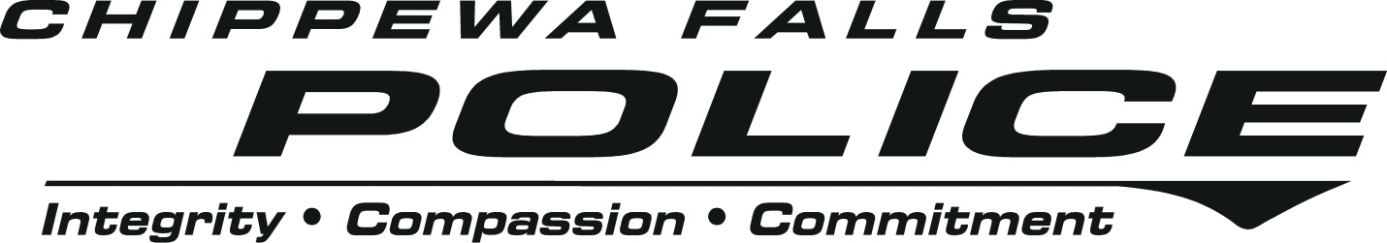
2019 CHIPPEWA FALLS POLICE DEPARTMENT HIRING PROCESS
We have revised our hiring process to get the best candidates identified and hired as quickly as possible. Our process favors face-to-face contact when determining who to move forward. Although our process has been streamlined, it remains involved and selective.
There are few careers that require a higher level of public trust. It takes a special person to be a police officer here. We hire the best and that is who you will be working with every day.
This process is used to fill an immediate vacancy and to create an eligibility list for any potential future vacancies in 2019.
If you have any questions please call Julie Johnholtz at 715-726-2707 or email
jjohnholtz@chippewafalls-wi.gov
- Applications accepted through April 25
  - Applications may be emailed to jjohnholtz@chippewafalls-wi.gov by April 25th at 4 pm
  - Applications may be dropped off at the Police Department by April 25th at 4 pm
  - Applications may be mailed, but must be postmarked by April 19th
    - Chippewa Falls Police Department, 210 Island St, Chippewa Falls, WI 54729
- Assessment Center is on April 27
  - The Assessment Center begins at 8:00 am on April 27 at the Chippewa Falls Police Department. We will contact you once we have received your application to assign your time.
  - Each candidate will receive an initial interview
  - Those who are moved forward will then take a Personal Evaluation Profile test
  - A physical agility test be held at 2:00 pm that afternoon
    - Please note: If you have successfully completed the Wisconsin Police Academy Graduation Standard test (see below) within the last 12 months, this test may be waived. Please contact Julie Johnholtz at 715-726-2707 or jjohnholtz@chippewafalls-wi.gov
  - The location of the physical agility test will be provided at the Assessment Center
  - The test is the Wisconsin Police Academy Graduation Standard test
    - 1.5 mile run
    - 100 meter sprint
    - Push-ups
    - Sit-ups
    - Standing Jump

- Internal Police Department Panel Interview on May 3
  - Candidates will be interviewed by a panel of CFPD officers of all ranks
  - Interview will consist of questions, interactive scenarios, and a written report
- Police and Fire Commission Final Interview and Candidate Selection - TBD
- Comprehensive Background Check
- Psychological/Medical/Drug Tests
- Start Date

Why apply for the Chippewa Falls Police Department?
The Chippewa Falls Police Department is a very special place to work. We provide professional police services to a city of 14,000. The size of our police department is a perfect balance for officers who are looking for opportunities early on and throughout their careers but desire to work with a close-knit group of officers. We look for ways to invest in our officers, including in-house and outside training opportunities. We have a history of promoting a feeling of family and teamwork here at the Chippewa Falls Police Department and we live our values of Compassion, Commitment, and Integrity every day. We do allow our officers to have neatly trimmed facial hair as well as non-offensive visible tattoos with permission from the Chief. Please take time to explore our website and look at what we are all about.
Many people come into the police field looking to specialize in areas they are passionate. We have many opportunities including Internet Crimes against Children, SWAT, Sensitive Crimes, Tactical and Firearms Instructors, Bike Patrol, Social Media and Public Information, Honor Guard, Financial Crimes, Drug Investigations, Evidence Technician, School Resource Officer, and through strong public support we now have a K9 program. If there is an area of law enforcement you are interested in, chances are we have it, and you will have an opportunity to play an important role.
We are passionate about serving our community here in Chippewa Falls. The City of Chippewa Falls is a growing community located a short distance from Eau Claire and about 90 minutes from the Twin Cities. Our community is known for its small town feel with generous and friendly citizens. We have several parks including Irvine Park with its’ zoo and the new Riverside and Erickson Parks. We also have the Northern Wisconsin State Fairgrounds that hosts many events annually. The recreational opportunities and excellent schools here in Chippewa Falls make it a great place for families.
If you feel this is the kind of community you would like to serve, please apply today.

